Written Response – Unit 2
Source Analysis

Write a source analysis paper in which you respond to the three sources below, and connect them to our unit issue:
In times of conflict, to what extent are nationalism and ultranationalism expressions of the pursuit of national interests?

Remember to interpret each source, explain the perspective(s) reflected in the source and discuss the links between globalization in each source Make sure you identify and explain one or more of the relationships that exist among the three sources

Reminders for Writing:
- brainstorm first
- organize your ideas (similar ideas together)
- proof read your work
- use academic language

Source 1

Source 2

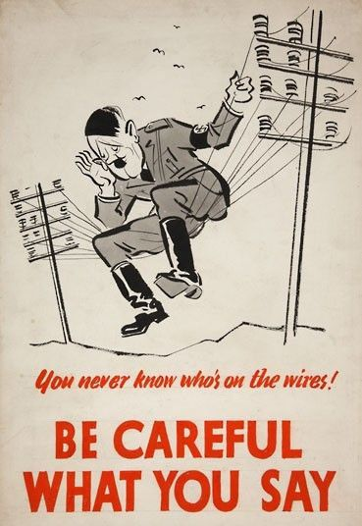

Source 3

YOU PICK!
Pick any piece of WW1, WW2, or other piece of propaganda.
If you would like me to provide you with a piece, please ask.

