***Use the following source to answer question 1***

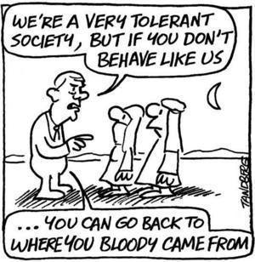

1. The perspective of the source is suggesting a view of Canadian nationalism that includes which of the following statements?

1. Canada is a tolerant nation
2. Canada embraces immigrants from around the world
3. Canada encourages assimilation to ensure a homogenous society
4. Canada refuses immigrants who try to enter from non-European nations

***Use the following source to answer question 2***

|  |
| --- |
| **Components of a National Identity** |
| 1- the image we have of individuals and groups |
| 2- the similarities we have with other countries |
| 3- the way in which we achieve prosperity |
| 4- the image other countries have of us |

2. Which of the following components is MOST consistent with the idea of **national** identity?

* 1. 1 and 2
  2. 2 and 3
  3. 3 and 4
  4. 2 and 4

***Use the following sources to answer questions 3 & 4***

“When the [French] King called for an Estates-General in 1789, the social tensions plaguing the old regime emerged as a central issue of the Revolution. Many pamphlets appeared suggesting that representatives should vote by "head" rather than by "order" (meaning all representatives should vote together as a single assembly, rather than as three separate bodies representing three separate orders).

3. The writers of these pamphlets would **MOST** likely have been

a. the Nobles, who were dissatisfied with the privileges of the First Estate

b. the Third Estate, who were demanding a fairer voting system

c. the priests, who felt that a change to the system was in order

d. the members of both the First and Second Estate who felt that change was needed

4. The **MAIN** reason for demanding a vote by “head” rather than by “order” was

a. under the existing system the First and Second estate would “gang up” on the Third Estate

b. the First Estate would have more clout, being the largest group, if voting was by “head”

c. the Third Estate, being the smallest group, would get some representation if the voting was

by “head”

d. the Second Estate could retain its power over the First and Third Estates if voting were by

“head”

1. The act of resolving differences and repairing relationships is known as:
   1. Reconciliation
   2. Cultural pluralism
   3. Reasonable accommodation
   4. Patriotism
2. The Oka Crisis unfolded due to:
   1. A planned condominium expansion to a golf complex on land claimed by the local Aboriginal community that would have encircled an Aboriginal cemetery
   2. A stand off between a Mohawk and an RCMP officer over a border dispute
   3. The blocking of the Mercier Bridge by the Canadian Army
   4. John Ciaccia, Quebec’s Native Affairs Minister, making comments about the profits that could have been made from retail development in the area

***Use the following sources to answer questions 7, 8, and 9***

|  |
| --- |
| **Speaker 1:** The Paris peace agreement has treated the German people harshly. Germany is to accept sole blame for the war and must pay a huge indemnity to the victorious Allies. In addition, Germany has been stripped of her colonies and much of her territory. Germans will long remember this outrage and will prepare to take revenge. |
| **Speaker 2:** Germany got only what she deserved. If she had won the war, the Allied Powers would no doubt have been dealt with even more harshly. Germany started the war and was primarily responsible for the lengthy resistance of the Central Powers. Without Germany, there would have been no war, and therefore, she should be made to pay for the damage she helped cause. |
| **Speaker 3**: How can the German people be held responsible for the actions of an autocratic and ruthless regime? Post-war Germany is no longer an autocracy. The German people have thrown out their arrogant and foolish leaders and replaced them with democratic institutions. It was the Kaiser and his ministers who were primarily responsible for Germany entering the war and it is they who should accept the blame. |
| **Speaker 4**: Germany was to blame for the war, but so were the Austrians, so were the Russians, so were the French, and so were the British. It seems quite unfair to single out one nation and lay all of the blame on her doorstep. |

7. The two speakers whose points of view over the treatment of post WWI Germany **differ most**

are speakers

* 1. 1 and 2
  2. 1 and 3
  3. 2 and 3
  4. 3 and 4

8. The perspective illustrated by Speaker 2 is **closest** to the perspective of which national

perspective?

* 1. USA
  2. France
  3. Britain
  4. Japan

9. Speaker 4 would **most strongly disagree** that which of the following was the MAIN cause of

World War I?

1. The assassination of Arch duke Franz Ferdinand
2. The complex alliance system of the Triple Entente and Triple Alliance
3. Imperialist policies of Russia and Austria-Hungary toward the Balkan states
4. The adoption of militarism by Britain and Germany resulting in a naval arms race

***Use the following quote to answer question 10***

|  |
| --- |
| It is not easy to see how extreme forms of nationalism can long survive when men have seen the Earth in its true perspective as a single, small globe amongst the stars.  Arthur C. Clarke |

10. Which of the following would Mr. Clarke **MOST** agree with?

1. Nationalism as it now exists will develop into ultranationalism
2. Extreme nationalism has encouraged humankind to view each other as a powerful global nation
3. When people perceive that the earth is merely a “single small globe”, he will no longer feel this place is worth celebrating
4. As globalization progresses, ultranationalism will decrease as different nations begin to understand that we are all members of the same planet

11. The principle of liberal internationalism is demonstrated when nations attempt to establish

1. Colonial empires
2. Unilateral agreements
3. Isolationist policies
4. Multilateral agreements

***Use the following information to answer question 12***

*“Canada took a principled stand against participating in military intervention in Iraq. From the beginning, our position has been clear: to work through the UN to achieve the goals we share with our friends and allies”*  
 - Prime Minister Chretien to the House of Commons, April 8, 2003

1. In the source above, the Canadian government is demonstrating its commitment to:
   1. The United Nations Democratic Process
   2. Humanitarian Aid
   3. Hegemonic Internationalism
   4. Isolationism
2. Which of the following organizations provides economic assistance to struggling economies?
3. WTO
4. IMF
5. NAFTA
6. NATO
7. Which of the following is **least likely** to be identified by Canadians as a “vital national interest” of Canada?
8. foreign aid
9. state survival (continuation of the existence of a country)
10. national unity
11. national security

***Use the following information to answer question 15***

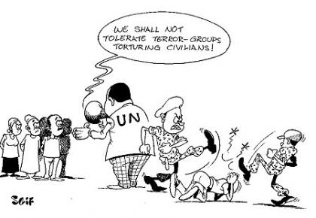

1. What is the cartoon’s primary message?
2. The UN is well aware of the abuses in its own member states
3. Human right abusers often hide behind the slow and careful policies of the UN
4. The UN is unable to force military dictatorships to become more democratic
5. Terror groups are not allowed to torture civilians and the UN often acts swiftly and efficiently to solve these issues.
6. Which of the following provisions of the Treaty of Versailles **best** reflected the principle of national self-determination for ethnic groups?

A. Germany was forbidden to have an air force or submarine fleet

B. The victors in the First World War received reparation payments

C. Yugoslavia, Poland, and Czechoslovakia became independent countries

D. Signing nations automatically became members of the League of Nation

***Use the following source to answer questions 17, 18, and 19***



17. According to the source, the United States thinks it’s protected from the effects of

A. Soviet communism

1. Italian epidemic disease
2. European ultranationalism
3. German economic failures

18. The source is criticizing the foreign policy of

A. ultranationalism

1. isolationism
2. aggression
3. appeasement

19. The use of this policy by the United States ended with

A. the Battle of Britain

1. the allied invasion of Normandy
2. Germany's invasion of the USSR
3. the Japanese Bombing of Pearl Harbor

***Use the following sources to answer question 20***

|  |
| --- |
| **Source I**  Let us consider briefly the program which Hitler laid down for himself. It was a program of Eastern expansionism, entailing a war of conquest against Russia…. In order to carry it out, Hitler needed a restored Germany, which since it must be powerful enough to conquer Russia, must also be powerful enough to conquer the West if that should be necessary. And that might be necessary even before the attack on Russia… it was always possible that a war with the West would be necessary before he could march against Russia. And in fact that is what happened.  -source from *The World This Century* |

20. Hitler’s “program of Eastern expansionism” was founded on the concept of

1. Kristallnacht (Night of Broken Glass)
2. Lebensraum (living space)
3. Schlieffen Plan
4. Anschluss (occupation of Austria)

21. Explain the **“domino effect”** caused by the assassination of the Austrian-Hungarian archduke.

* 1. Austria-Hungary declared war on Serbia, Russia defended Serbia, Germany defended Austria-Hungary, and France backs up Russia.
  2. Germany declared war on Serbia, Russia defended Germany, France defended Austria-Hungary, and USA backs up Russia.
  3. Austria-Hungary declared war on Serbia, Britain defended Serbia, Germany defended Austria-Hungary, and USA backs up Russia.
  4. Austria-Hungary declared war on Serbia, Italy defended Serbia, Germany defended Austria-Hungary, and Britain backs up Russia.

22. What was the Military Service Act?

1. Allowed the government to arrest and detain suspected spies.
2. Required men of military age to register and face conscription
3. Recruited men of military age to serve on the home front.
4. Gave the government power to intern suspected spies.
5. What was the War Measures Act?
   1. Allowed the government to arrest and detain suspected spies.
   2. Required men of military age to register and face conscription
   3. Recruited men of military age to serve on the home front.
   4. Gave the government the power to confiscate alcohol so that soldiers would not get intoxicated.

***Use the source to answer question 24***

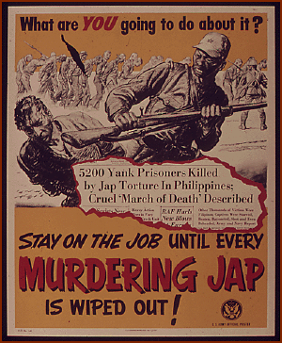

*American poster of early 1940’s.*

1. What propaganda technique is **best** portrayed in the source?

A. plays on peoples’ own failures

B. card stacking by presenting the Japanese in a positive light.

C. uses respected symbols to appeal to the values of people

D. appeals to people’s fears to persuade them to support a particular action

1. Holodomor refers to
   1. The artificial famine in Ukraine in 1932-33
   2. Nazi Germany’s attempt to exterminate the Jews of Europe
   3. The first of two Japanese cities to be destroyed by atomic bombs in 1945
   4. The reign of Czechoslovakia that was handed over to Nazi Germany in the Munich Pact